ALFA HBLED 1M SANDRA

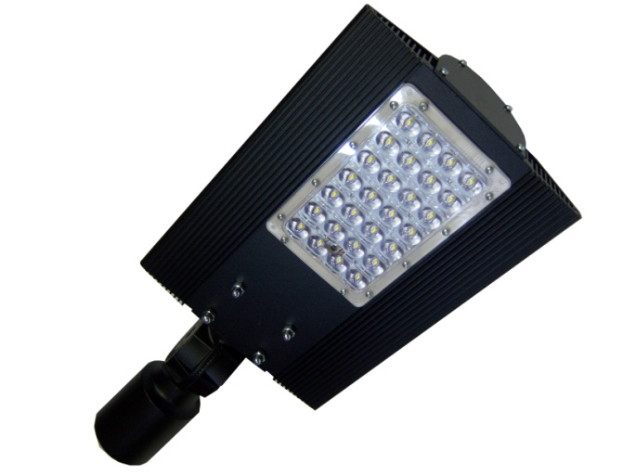
Professional LED 30 lamps equipped with individually programmable module controlling the electricity usage, with the latest HBLED technology used as a light source.
The luminaire may optionally be equipped with
an individual motion sensor.

APPLICATION

- Roads, streets
- Alleys, pavements
- Bicycle paths
- Parking places
- Industrial zones
- Residential areas

MOUNTING SYSTEM

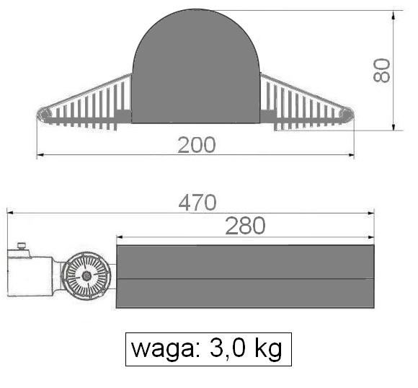

- Can be mounted on a pole peak. Unified tip diameter of 42 to 60 mm.
- Can be mounted on the boom side. Unified tip diameter of 42 to 60 mm.
- Adjustable joint allows smooth change of the inclination angle relative
to the illuminated surface. -35^{O} + 45^{O}.

Wieight: 3,0 kg
STREAM LIGHT

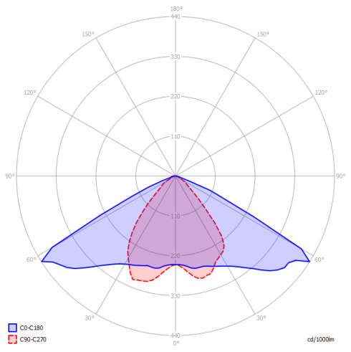
Power strength | The Luminous Power
30 [W] | 3.360 [lm]

Due to technical progress may be varied

ALFA HBLED 1M SANDRA

TECHNICAL DATA

Voltage power | 230 AC
power consumption | 30[W]
Light source | 28 x HBLED 1W, CRI ≥ 80%
Frequency power | 50/60 [Hz]
Level of protection | IP 66
IK Shock-Protection Rate | IK 09
WFactor distortions THD | <15 [%]
Power factor cos α | >0,95
Time ignition | <1 [s]
Range work | -40 [°C] do +55 [°C]
Guarantee | 5 year
Costruction | Modular
Binding | Aluminium
Optical system | Polycarbonate
Temperature colour | Neutral: 3.650 [K] – 4.300 [K]  Cold: 5.300 [K] – 6.700 [K]
motion sensor | YES - optional

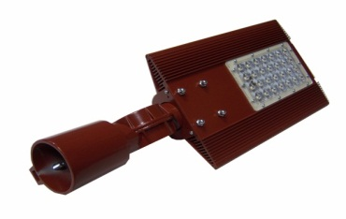
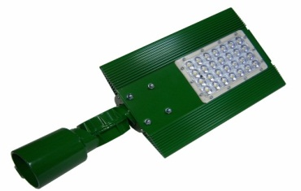
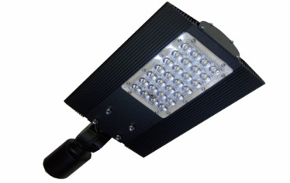
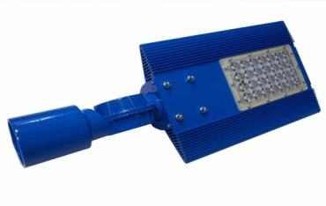

Coloring - standard Coloring - other version
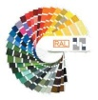
Black - RAL 9005 the individual needs of
Grey - RAL 9006 versions available as
RAL palette

PRODUCER OF ILLUMINATION
ALFA HBLED
Poland, 62-800 Kalisz
ul. Kolejowa 15
biuro@hbled.pl www.hbled.pl

